**Project Design Phase-II**

**Data Flow Diagram & User Stories**

|  |  |
| --- | --- |
| Date | 18th October, 2022 |
| Team ID | PNT2022TMID02425 |
| Project Name | Web Phishing Detection |
| Maximum Marks | 4 Marks |

**Data Flow Diagrams:**

A Data Flow Diagram (DFD) is a traditional visual representation of the information flows within a system. A neat and clear DFD can depict the right amount of the system requirement graphically. It shows how data enters and leaves the system, what changes the information, and where data is stored.

**Example:**

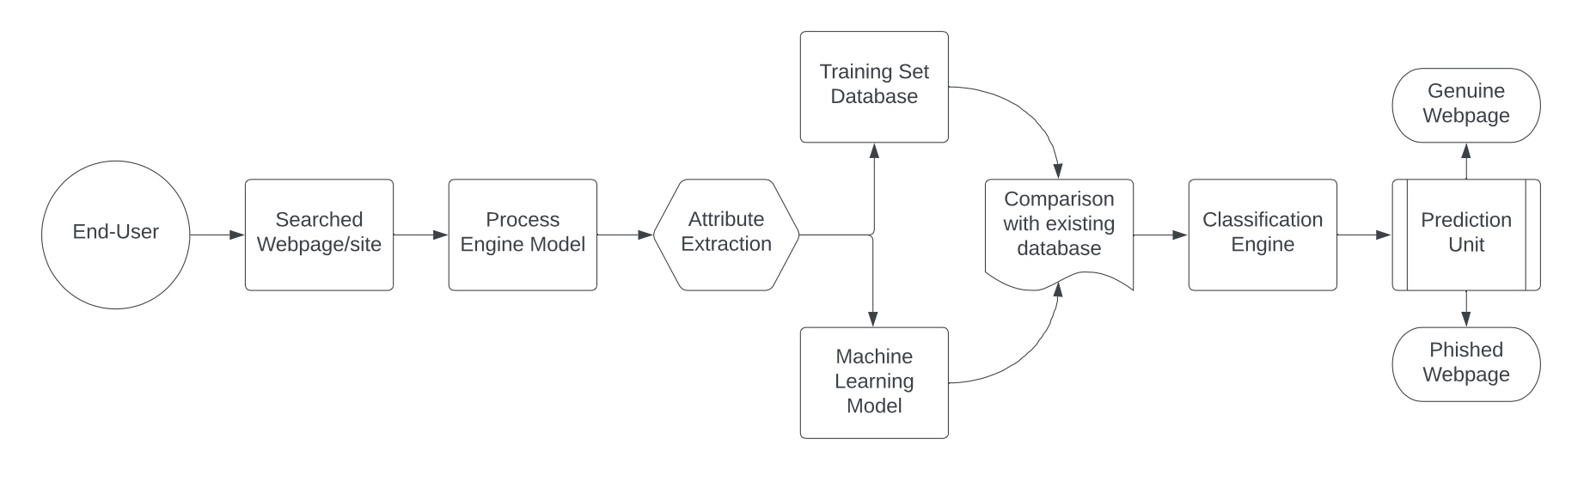

**User Stories**

| **User Type** | **Functional Requirement (Epic)** | **User Story Number** | **User Story / Task** | **Acceptance criteria** | **Priority** | **Release** |
| --- | --- | --- | --- | --- | --- | --- |
| Customer  (Web User) | Registration | USN-1 | As a user, I can register by crediting with login credentials like email address, password, and confirming my password. | I can access my account / dashboard | High | Sprint-1 |
|  |  | USN-2 | As a user, I get acknowledged by a token of confirmation via email. | I can get confirmation link via email | High | Sprint-1 |
|  |  | USN-3 | As a user, I can double verify by using a double factor authentication. | I can add more security keys to maintain privacy | Medium | Sprint-2 |
|  |  | USN-4 | As a user, I can finally login/ access a webpage that does not re-direct to other webpages. | I can cross-verify that stating it could be legitimate | Low | Sprint-1 |
|  | Login | USN-5 | As a user, I can log into the webpages by email address & password. | I can gain account resources and data | Low | Sprint-1 |
| Customer  (Web user) | Input | USN-6 | As a user, I share the website’s Unified resource locator to the Modal | I can upload the input to the modal | Low | Sprint-2 |
| Customer Care Executive | Attribute Extractor | USN-7 | Attribute Extrator and Process Engine works together to compare with Training and Testing Database to verify matching instances. | I can verify by comparison algorithm with existing database | High | Sprint-1 |
| Administrator | Algorithm | USN-8 | Machine learning and alogirthms are used to process apart from simple approach such as visual identification. |  | High | Sprint-1 |
|  | Result | USN-9 | The prediction unit confirms and finalise the resulting input webpage is genuine or not. | I can get the final verdict from the engine | High | Sprint-2 |